Software Requirements Specification

Project-1

Event Planning



|  |  |
| --- | --- |
| Prepared by:  Ankita Rao(PCE15IT006)  Ayushi Sharma(PCE15IT010) | Guide:  Ms Shazia Haque  (Associate Professor) |
| Department of Information Technology,  Poornima College of Engineering  Session 2018-19 | |
|  | |

Table of Contents

|  |  |
| --- | --- |
| Table of Contents | Page No. |
| 1. Introduction | 03 |
| 1.1 Purpose | 03 |
| 1.2 Feasibility | 03 |
| 2. Functional /Nonfunctional Requirements | 04 |
| 2.1 Functional Requirement | 04 |
| 2.2 Nonfunctional Requirements | 05 |
| 2.3 Technical Requirments ( Hardware /Software) | 06 |
| 3. Analysis Diagrams | 07 |
| 4.1 Class Diagram | 07 |
| 4.2 Usecase Diagram | 08 |
| 4.3 Activity Diagram | 09 |
| 4. Other Requirements | 11 |
| 5. Glossary | 11 |
| 6. Appendices | 11 |
| 7. References | 11 |
| 8. Guide’s Comments | 11 |

Revision History

|  |  |  |  |
| --- | --- | --- | --- |
| **Name** | **Date** | **Reason For Changes** | **Version** |
|  |  |  |  |
|  |  |  |  |
|  |  |  |  |
|  |  |  |  |

# Introduction

## 1.1 Purpose

To provide a system to manage all the events which the team or individual wants in near future in order to help users for suitable planning of Event. The main objective of the Project on Event Planning System is to manage the details of Event, Booking, Customer, Employee, and Volunteer. It manages all the information about Event, Package, and Enquiry. The project is totally built at administrative end and thus only the administrator is guaranteed the access. The purpose of the project is to build an application program to reduce the manual work for managing the Event, Booking, Package, and Customer. It tracks all the details about the Customer, Employee, and Enquiry.

**1.2 Feasibility**

**1.2.1 Operational Feasibility**: Operation of the proposed system depend on its

various users. These various user-types mentioned below.

* Admin
* Manager
* Normal User(Participants)/Volunteer

Admin will make managers for different events. And allocate Login ID.

Thereafter Normal User enters their details like Name, Event, Venue, Number of guest. Then manager will check user entries and will allot registration id for authentication purpose .Here manager responsible to check team size, details, manager is responsible to restrict unauthorized people or wrong entries.

**1.2.2 Social Feasibility**: Proposed system would be acceptable by the other

peoples. Because Online Event Planning is better than ordinary

registration process and management in the following issues:

* + Faster than other older systems
  + Database keeps records
  + Time saving

**1.2.3** **Economic Feasibility**: As no papers required so it reduce cost. It would

be beneficial because only one time development efforts required. All

people are aware of technologies so no special skills required to run the

system.

## Functional /Nonfunctional Requirements

## Functional Requirements

1. **User Registration:**

* The user need to register for accessing your website
* The user shall be able to register directly through E-mail or using mobile number.

1. **User Authentication:**

* The user can register or authenticate through Email.

### Email confirmation:

* The system will maintain customer email information as a required part of customer profile.
* The system will send a link confirmation to the user through email which will be required for the authentication of the user.

1. **Password Recovery:**

* The user can recover password though e-mail.

### Maintain customer profile:

* Users will be allowed to maintain and edit their user profiles.
* The system will authenticate user credentials to view the profile.

1. **System Administrator:**

* System Administrator can login into system.
* Administrator can monitor every activity of the user.
* Administrator can add delete or update data of individual events and venues.

1. **Analyze System features:**

The system should extract meaningful data provided by the user and store it in database.

The system should identify the events if it is present in database else the user request the admin to add a particular event.

The system will interact with various users.

1. **Analyze various parameters:**

* The system should analyze and note the users need of each and every event with its venue, requirements, number of guest and Event booking details.
* The system should be able to send notifications regarding the upcoming Events.

## 2.2 Nonfunctional Requirements

## 2.2.1 Performance Requirements

The system supports multiple users at the same time. The system need to be reliable. If unable to process the request then appropriate error message. Web pages are loaded within few seconds.

## 2.2.2 Security Requirements

The system must comply with the permission roles. Security in terms of unauthorized access must not be allowed. Also roles of each user should not be mixed which could result in instant damage of expected results. After entering the password and user id the user can access his profile. The details of user must be safe and secure.

## 2.2.3 Safety Requirements

The details need to be maintained properly. Users must be authenticated. The database must be kept backed up.

## 2.2.4 Software Quality Attributes

* **Scalability**: We can evenly increase the number of events and venues used in the database as required . Also , the captured data will be stored in database.
* **Manageability**: Cost will be shown to the registered user and all the details of volunteers will also be managed.
* **Extensibility**: System can be further extended to any level as it is a large scale project which could be further implemented by extending the number of events, venues and team and modules like view the users history and adding users response/feedback.
* **Usability**: As the existing system involves a lot of time to manage all the activities involved in planning a particular event at one place so to reduce the manual work we created a system that will efficiently store, maintain and retrieve the data regarding the event. The project will be very useful in planning weddings, Birthdays and festival ceremony.
* **Availability**: The system should be available 24 hours a day, 7 days a week. This statement provides a general sense of system availability. It is not intended to demand the system maintain reliability, or to require the system to be highly available. It should not exclude scheduled downtime; 99% up-time should be considered sufficient to meet this requirement.

## 2.3 Technical Requirments ( Hardware /Software)

## Operating Environment

Our application could be operated on various platforms which includes – Windows , Linux and MacOs and the data will be stored in Database . All this runs effectively with Internet connectivity as it is Online Event Planning portal.

## Hardware Interfaces

* RAM :2GB
* Processor: Pentinum-IV onwards

## Software Interfaces

* Languages Used to implement : Python 3
* Operating System: Windows
* Internet Browser: Mozilla/Google chrome
* Front End: HTML, CSS, Bootstrap
* Back End: MySQL
* Web server: Xampp
* Tool: PyCharm Professional Edition

# Analysis Diagrams

* **Class Diagram**

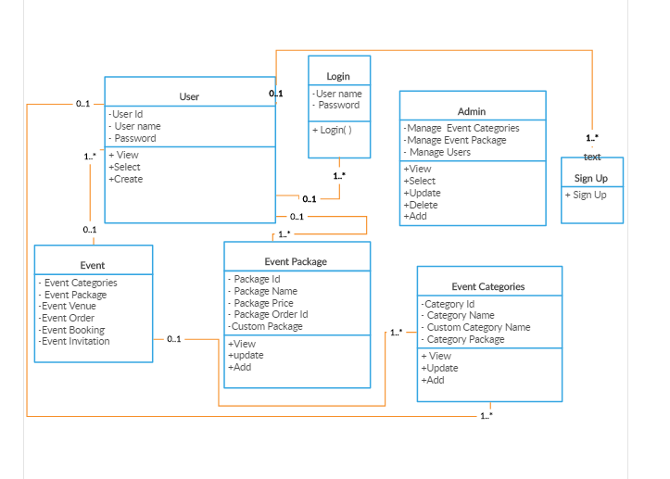

Figure 1 - Class Diagram

* **Use Case Diagram**

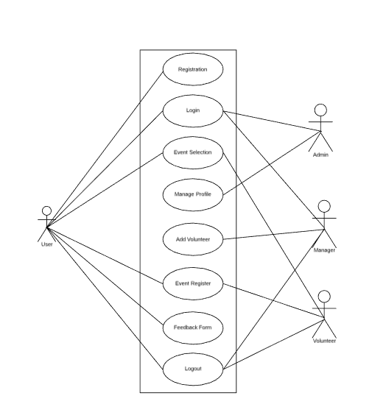

Figure 2 - Use Case Diagram

* **Activity Diagram**

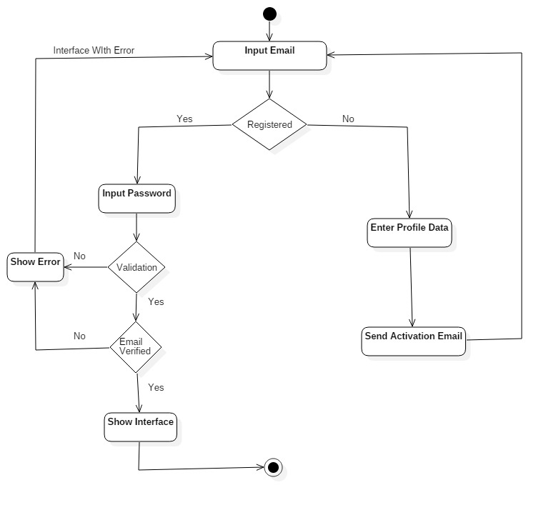

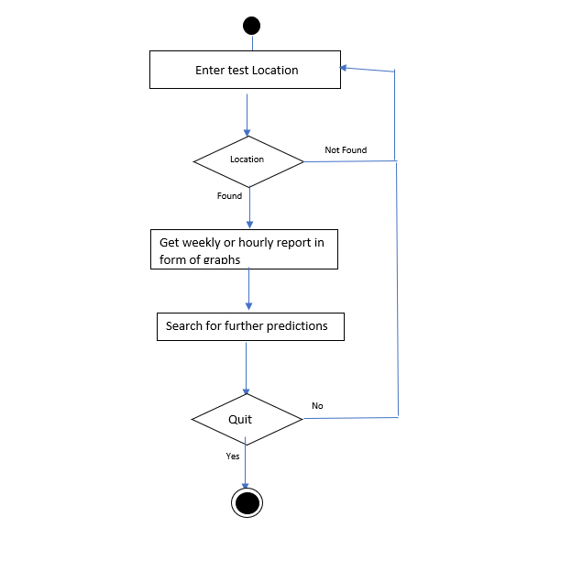

Enter Event and Venue

Calculate cost of event and Book the event

Enter all the requirement for the events with guest details.

Venue and

Figure 3 - Activity Diagram

# Other Requirements

The user can also select the event by the rating so in future we need to add on Blog and rating to each and every venue .so the new user can check the rating and select the desired venue.

# Glossary

There is no as such abbreviations involved in the SRS .The term user in the SRS refers to the individual or team of school, college or family for event booking.

# Appendices

Class Diagram : Page 7

Use Case : Page 8

Activity Diagram : Page 9-10

# References

[www.mpiweb.org](http://www.mpiweb.org)

[www.w3school3.com](http://www.w3school3.com)

[www.stackoverflow.com](http://www.stackoverflow.com)

[www.creatively.com](http://www.creatively.com)

[www.academia.com](http://www.academia.com)

# Guide’s Comments